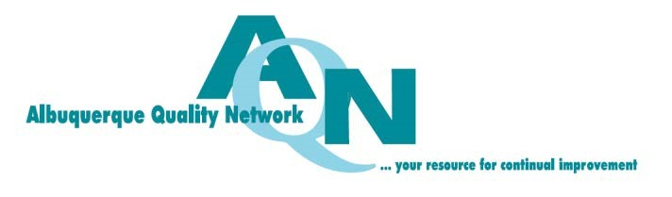

Group Registration Form - Annual Breakfast
January 19, 2017
Albuquerque Marriott, 2101 Louisiana Blvd, NE

Group Reservations: list attendees for admission at $35 per person and payment info. Use extra pages as needed.

Corporate Partners: use this form to register attendees for your complimentary admissions per your partnership level. You may also register additional PAID admissions using this form. Corporate Partners receive complimentary admissions to our annual breakfast per sponsorship level as follows:

Diamond Corporate Partners ($5000) – 10 admissions
Ruby Corporate Partners ($2500) – 5 admissions
Sapphire Corporate Partners ($1500) – 2 admissions

 | First Name | Last Name | Email
1
2
3
4
5
6
7
8
9
10

No. of Complimentary Admissions ($0) No. of Paid Admissions ($35 per person) Total $
AQN Annual Breakfast Payment Form (for paid admissions only)
Organization Contact Name
Address
City State Zip Phone
Email Address
Payment Amount: $_ (Mail credit card payments - On line payment not available)
Check Purchase Order Invoice Credit Card Cash
Charge my credit card: VISA MasterCard
Card # Exp Date Security Code
Billing Address Zip Code
Name on Card Signature
SUBMIT TO: Albuquerque Quality Network ∙ PO Box 16165 ∙ Albuquerque, NM 87191-6165
To request an invoice, provide credit card info by phone, or for other information, please contact us at: aqn@aqnetwork.org

