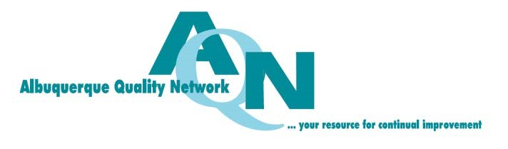

Group Registration Form – AQN Annual Breakfast
Thursday, January 18, 2018
Albuquerque Marriott Uptown Hotel; 2101 Louisiana Blvd, NE

Group Reservations: List attendees for admission at $35/person and payment info. Indicate requests for vegetarian meals.

Corporate Partners: Use this form to register attendees for your complimentary admissions per your partnership level. You may also register additional PAID admissions using this form. Corporate Partners receive complimentary admissions to our annual breakfast per sponsorship level as follows:
Menu
Diamond Corporate Partners ($5000) – 10 admissions Fluffy Scrambled Eggs, Crisp Bacon Strips, Ruby Corporate Partners ($2500) – 5 admissions Sausage Links, Breakfast Potatoes, Breads
Sapphire Corporate Partners ($1500) – 2 admissions

 | First Name | Last Name | Email | Vegetarian Meal? (Y)
1
2
3
4
5
6
7
8
9
10

No. of Complimentary Admissions ($0) No. of Paid Admissions ($35 per person Total $

AQN Annual Breakfast Payment Form (for paid admissions only)
Organization Contact Name _________________________Phone _________________
Address ___________________________ City ______________________ State ___________Zip ___________
Email Address _____________________________________
Payment Amount: $ ________________ (Please mail credit card payments* - Online payment not available)
Check Purchase Order Invoice Credit Card Cash
Charge my credit card: VISA MasterCard
Card # _________________________________________________ Exp Date Security Code ________
Billing Address Zip Code _______________
Name on Card Signature _____________________________________
SUBMIT TO: Albuquerque Quality Network ∙ PO Box 16165 ∙ Albuquerque, NM 87191-6165
*To request an invoice, to provide credit card info by phone, or for other information, please contact us at: aqn@aqnetwork.org

